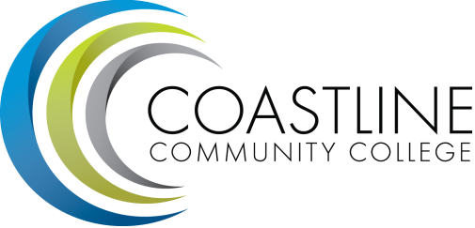

Classified Senate Meeting Agenda

DATE: January 15, 2015
MEETING: Classified Senate
LOCATION: College Center, 4th Floor Conference Room
TIME: 10 am to 12 pm

Approval of Minutes (5 minutes):

Fundraising Update (10 minutes):

Presentation:
  - Accreditation Follow-up Report (Gayle Berggren)

2014 - 2015 Participation (10 minutes):

Committee Reports (10 minutes):
  - College Council:
  - College on track to meet or exceed our FTE base for the year.
  - Coastline is the 3rd fastest growing CC in California.

Hot Topics (10 minutes):

Next Meeting: February 19, 2015

